Inviting an applicant to submit their application

You can generate an email invite to an applicant(s) inviting them to submit their application, from within the eBulk dashboard. This can be done by clicking the ‘Create Invite’ button at the top of the dashboard.

You will be taken to the invitation page where you can generate your invite (screenshot 6 below).

- You will need to select the ‘Organisation’ that you wish the applicant to create their application under, you will be able to select any organisations that you are linked to. You will then need to select the level of check that you require the applicant to submit from the ‘Channel’ drop-down field below.
- You are then required to enter the applicant’s forename, surname and email address into the boxes provided. If you wish to invite more than one applicant to create this specific level of check for this specific organisation you can click the ‘Add Candidate’ button as many times as required to invite multiple applicants.

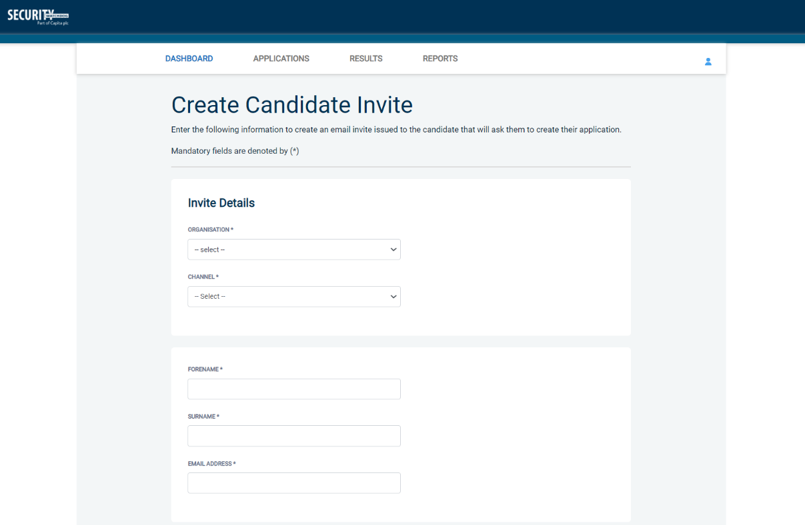
Screen Shot 6

- If you need to invite a large list of individuals, you can use the ‘Bulk Upload’ feature instead allowing you to upload a spreadsheet of applicants to be invited (screenshot 7 below). If you wish to use this feature, please leave the forename, surname, and email address fields blank and instead upload a pre-created spreadsheet. A blank template is provided in the eBulk footer if required. The spreadsheet must contain 3 columns only (Forename, Surname, Email address), any invalid data contained in the spreadsheet when uploaded will fail validation and be highlighted to you at the top of the screen.

Screen Shot 7
- Next, you are required to select a template from the ‘Email Template’ drop-down field (screenshot 8 below). You will be able to choose from either a ‘New Starter Invite Email’ or a ‘Renewal Invite Email’. Selecting one of these will populate the content of the invite email on-screen for you to review and amend if required. The pre-populated wording of these templates will either be the default wording coded into our system or a bespoke template for your organisation.
- Finally, click ‘Send’ to generate the invite to issue the invite to the applicant(s) entered.

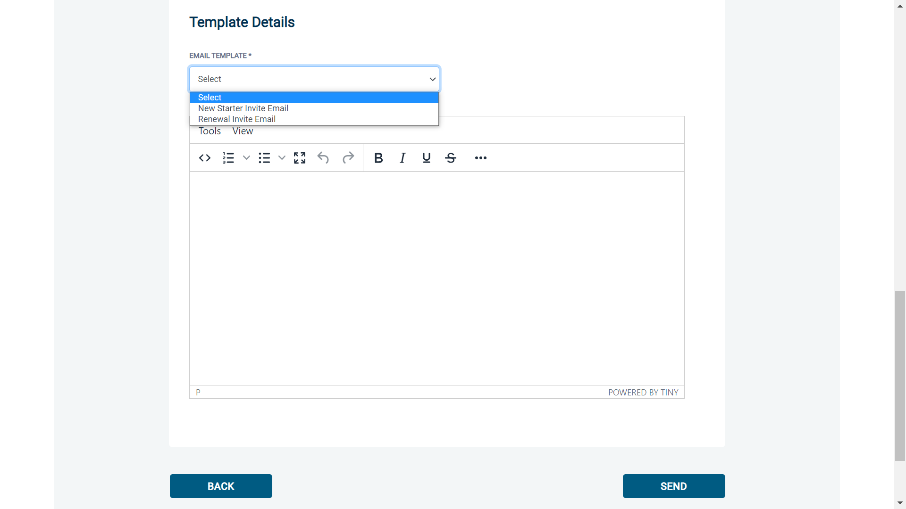
Screen Shot 8

